**Artificial Intelligence Lab**

**LAB 6 – Implementation of minimax algorithm for an application**

**Aditya Kumar**

**RA1911030010100**

**O2 Section**

**Date – 25/2/22**

**Problem Statement :**

Implementation of minimax algorithm for Tic Tac Toe.

**Algorithm :**

1. Get input from user between X and O
2. Make a state for every move
3. For each state run minimax function
4. If its X’s turn, return maximum score
5. If its O’s turn, return minimum score
6. Using the score, place the symbol other than the player on the board

**Code :**

def ConstBoard(board):

print("Current State Of Board : \n\n");

for i in range (0,9):

if((i>0) and (i%3)==0):

print("\n");

if(board[i]==0):

print("- ",end=" ");

if (board[i]==1):

print("O ",end=" ");

if(board[i]==-1):

print("X ",end=" ");

print("\n\n");

def UserTurn(board):

pos=input("Enter X's position from [1...9]: ");

pos=int(pos);

if(board[pos-1]!=0):

print("Wrong Move!!!");

exit(0) ;

board[pos-1]=-1;

def minimax(board,player):

x=analyzeboard(board);

if(x!=0):

return (x*player);

pos=-1;

value=-2;

for i in range(0,9):

if(board[i]==0):

board[i]=player;

score=-minimax(board,(player*-1));

if(score>value):

value=score;

pos=i;

board[i]=0;

if(pos==-1):

return 0;

return value;

def CompTurn(board):

pos=-1;

value=-2;

for i in range(0,9):

if(board[i]==0):

board[i]=1;

score=-minimax(board, -1);

board[i]=0;

if(score>value):

value=score;

pos=i;

board[pos]=1;

def analyzeboard(board):

cb=[[0,1,2],[3,4,5],[6,7,8],[0,3,6],[1,4,7],[2,5,8],[0,4,8],[2,4,6]];

for i in range(0,8):

if(board[cb[i][0]] != 0 and

board[cb[i][0]] == board[cb[i][1]] and

board[cb[i][0]] == board[cb[i][2]]):

return board[cb[i][2]];

return 0;

def main():

board=[0,0,0,0,0,0,0,0,0];

print("Computer : O Vs. You : X");

player= input("Enter to play 1(st) or 2(nd) :");

player = int(player);

for i in range (0,9):

if(analyzeboard(board)!=0):

break;

if((i+player)%2==0):

CompTurn(board);

else:

ConstBoard(board);

UserTurn(board);

x=analyzeboard(board);

if(x==0):

ConstBoard(board);

print("Draw!!!")

if(x==-1):

ConstBoard(board);

print("X Wins!!! Y Loose !!!")

if(x==1):

ConstBoard(board);

print("X Loose!!! O Wins !!!!")

main()

**Output :**

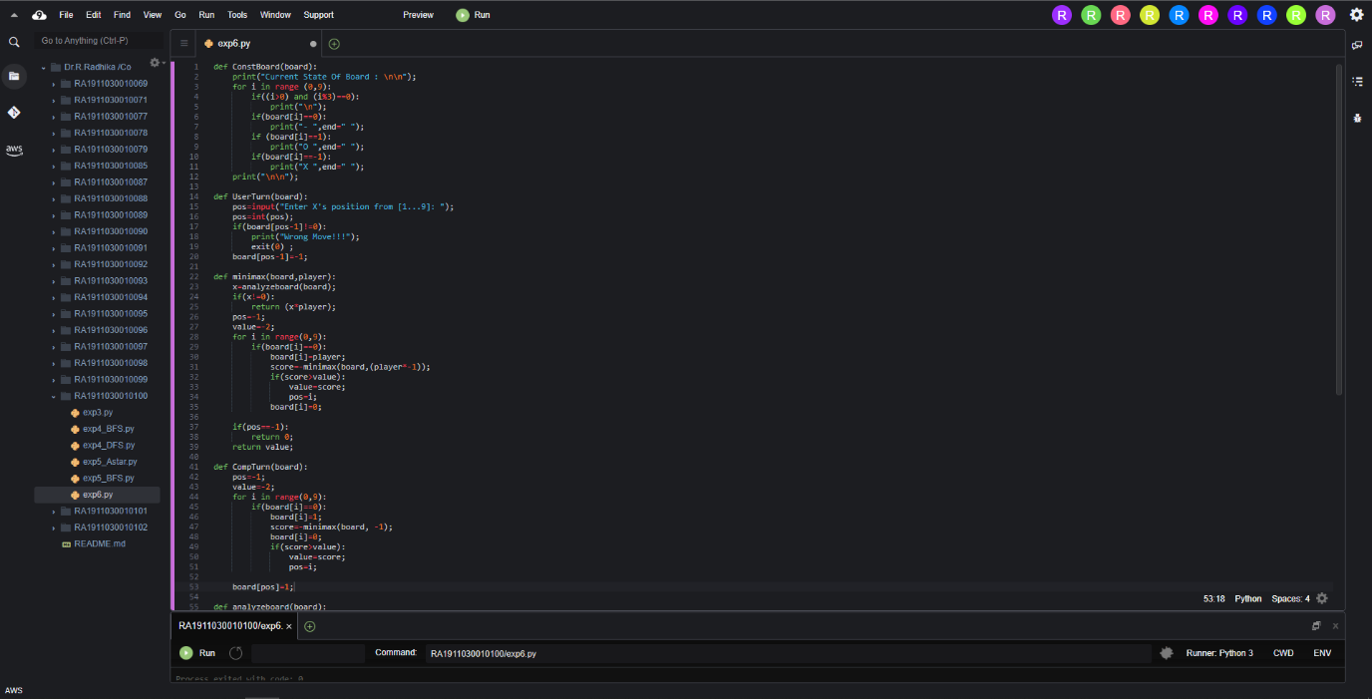

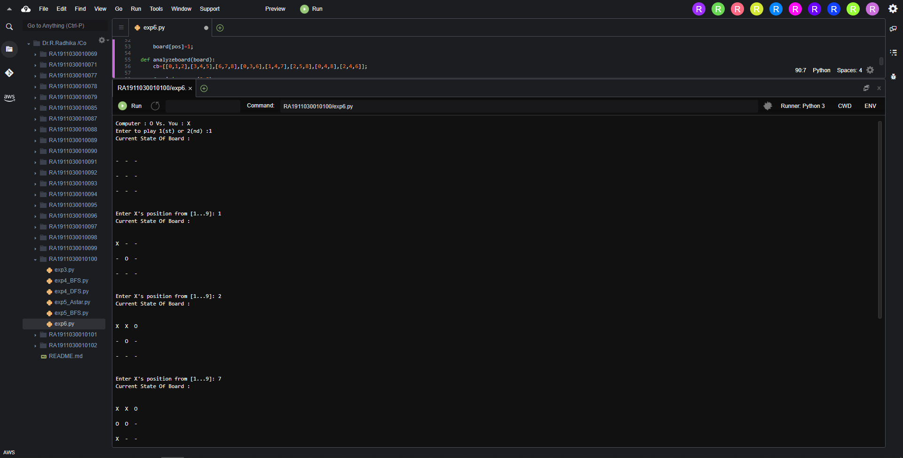

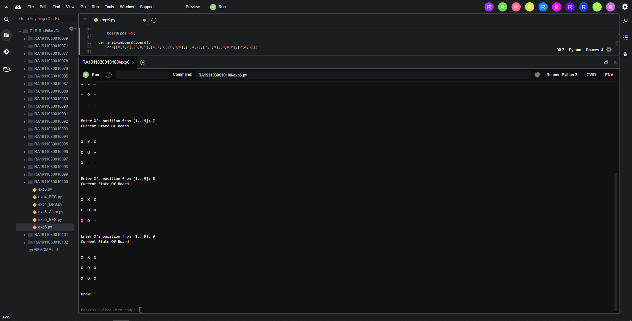

**Result :**

Hence minimax algorithm was implemented for Tic Tac Toe application.